|  |
| --- |
| Gene Function Prediction  Exploiting Ontology Graph for Predicting Sparsely Annotated Gene Function  Sheng Wang1,†, Hyunghoon Cho2,†, ChengXiang Zhai1, Bonnie Berger2,3and Jian Peng1,*  1 Department of Computer Science, University of Illinois at Urbana-Champaign, Urbana, IL, USA.  2 Computer Science and Artificial Intelligence Laboratory, MIT, Cambridge, MA, USA  3 Department of Mathematics, MIT, Cambridge, MA, USA |

**SUPPLEMENTARY INFORMATION**

# Two cluster structures discussed in Section 3.3

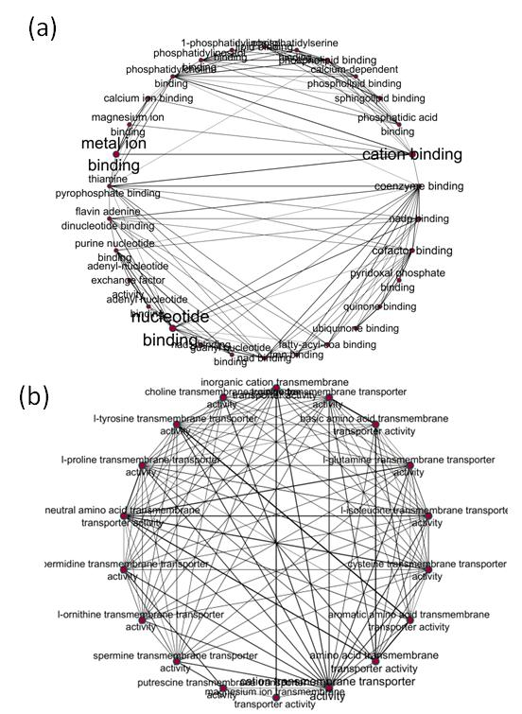

**Figure S1:** (a) The cluster structure of several binding functions. (b) The cluster structure of GO labels related to transmembrane transporting.

# Comparison of performance in terms of macro-AUROC

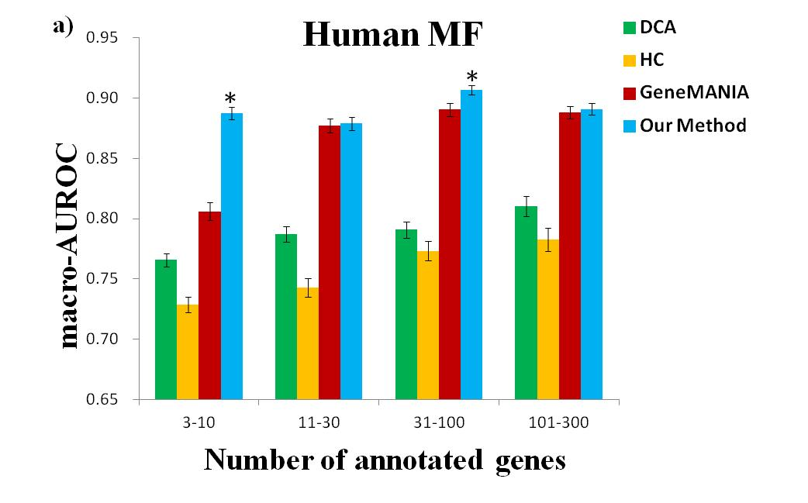

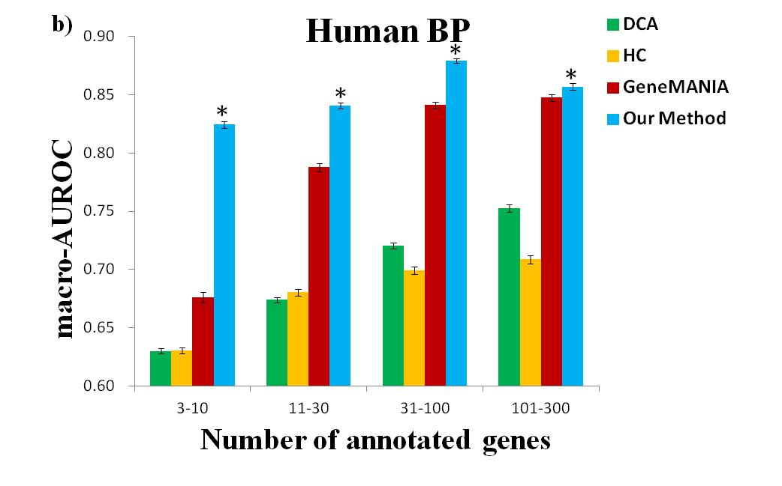

$\frac{∂{MAG}_{i}}{∂θ}=\frac{∂}{∂θ}\left(\frac{F_{i}^{M}B_{i}^{M}}{Z}\right)=\frac{∂F_{i}^{M}}{∂θ}\frac{B_{i}^{M}}{Z}+\frac{∂B_{i}^{M}}{∂θ}\frac{F_{i}^{M}}{Z}-\frac{F_{i}^{M}B_{i}^{M}}{Z}\frac{∂Z}{∂θ}$ 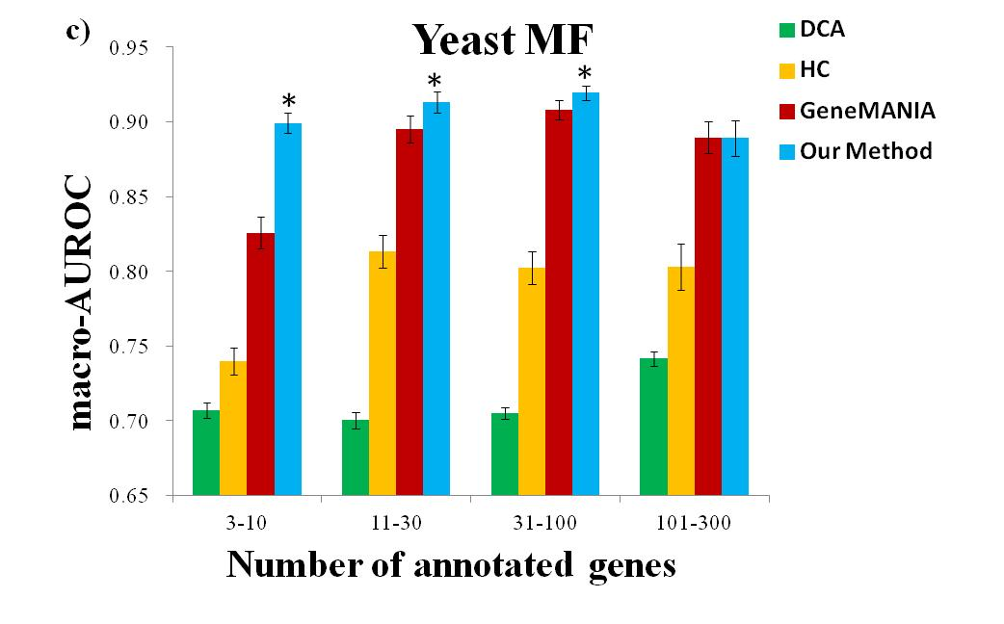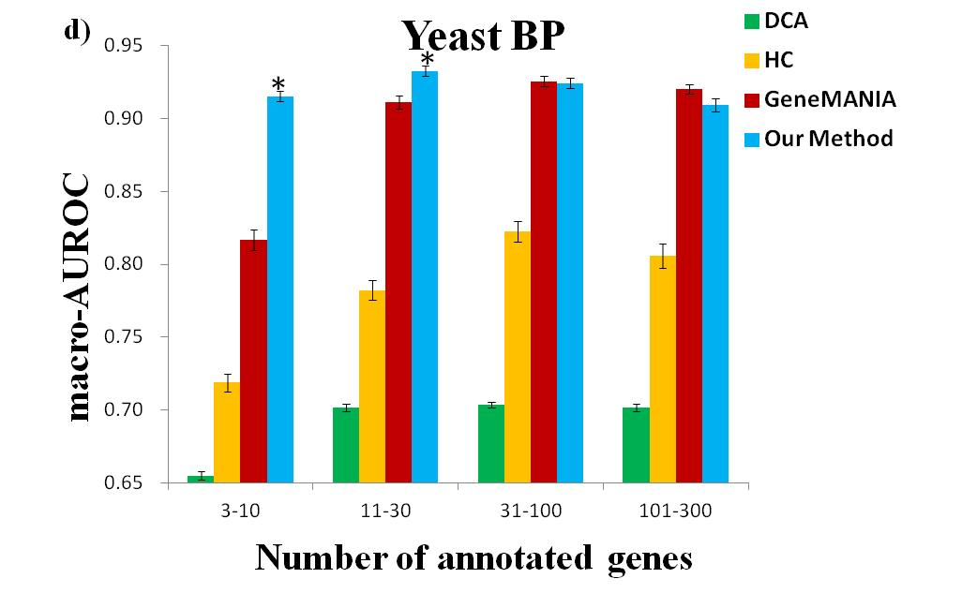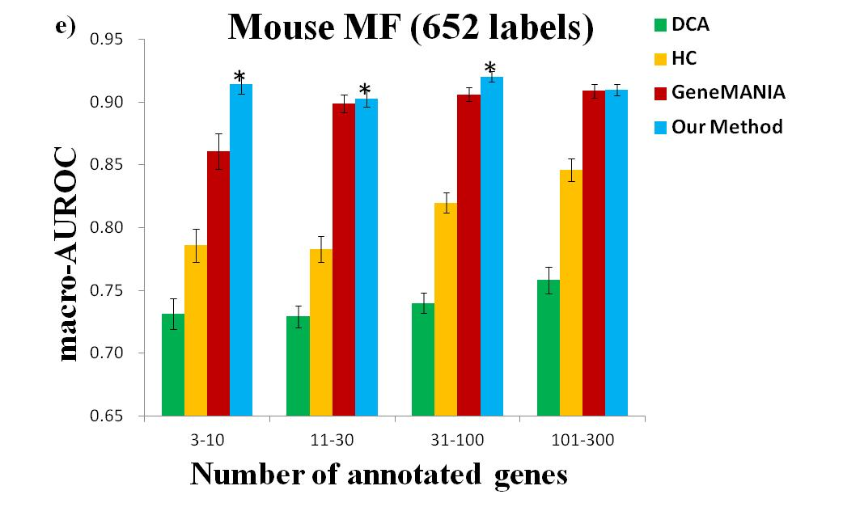

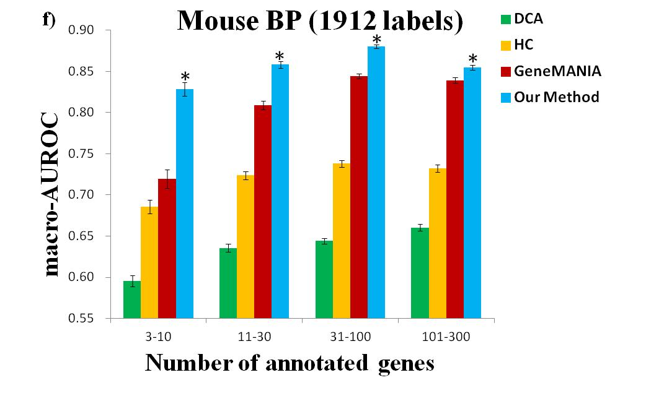

**Figure S2:** Comparison of our approach with other methods in terms of micro-AUROC. * indicates that our approach is statistically significant in comparison with GeneMANIA. Performance is evaluated for different subsets of GO labels with varying sparsity levels as shown on the x-axis.

# Comparison of number of dimensions discussed in Section 3.7

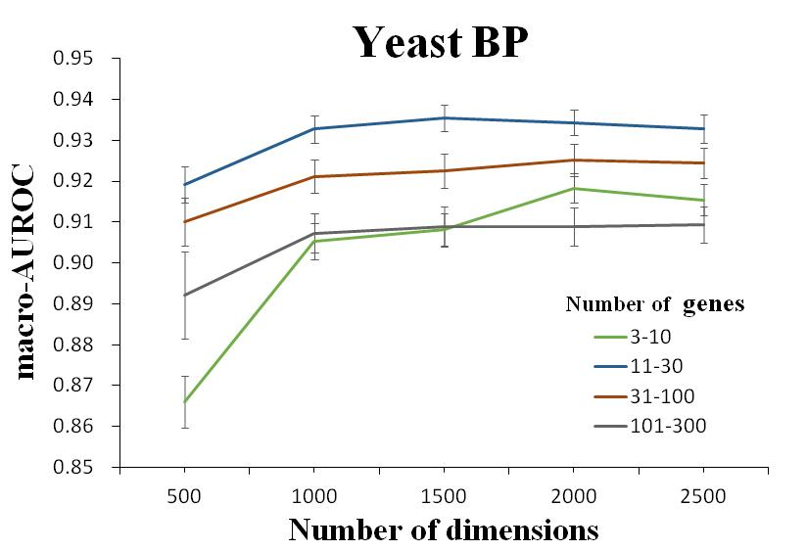

**Figure S3:** Comparison of number of dimensions in terms of macro-AUROC of biological process in yeast.

# Performance of clustering based on learned label vectors

Besides clustering GO labels based on the sparseness, we explored to cluster the GO labels based on learned label vectors. We denoted this method as vcDCA. We show the performance of this method in **Figure S4** and **Figure S5.**

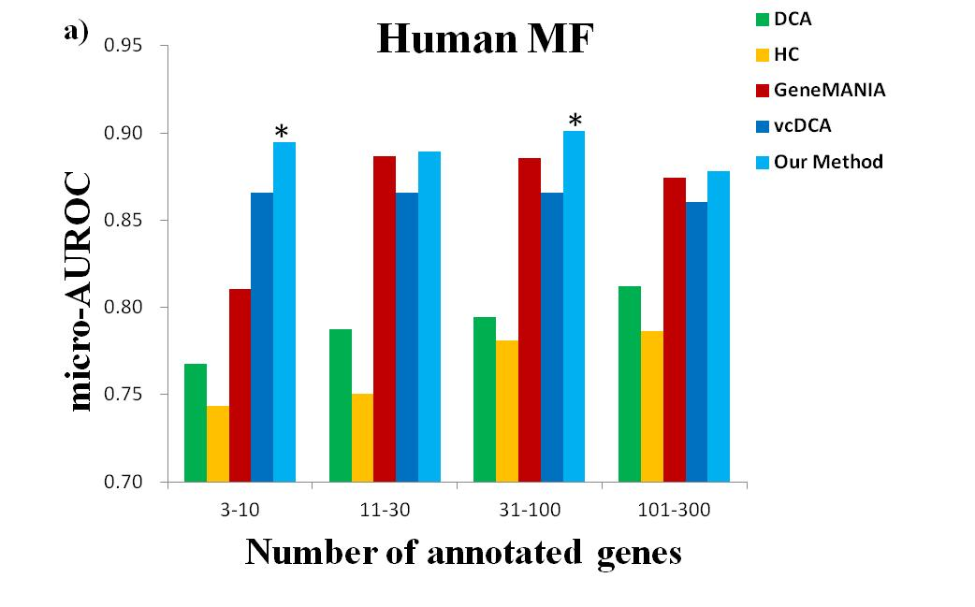

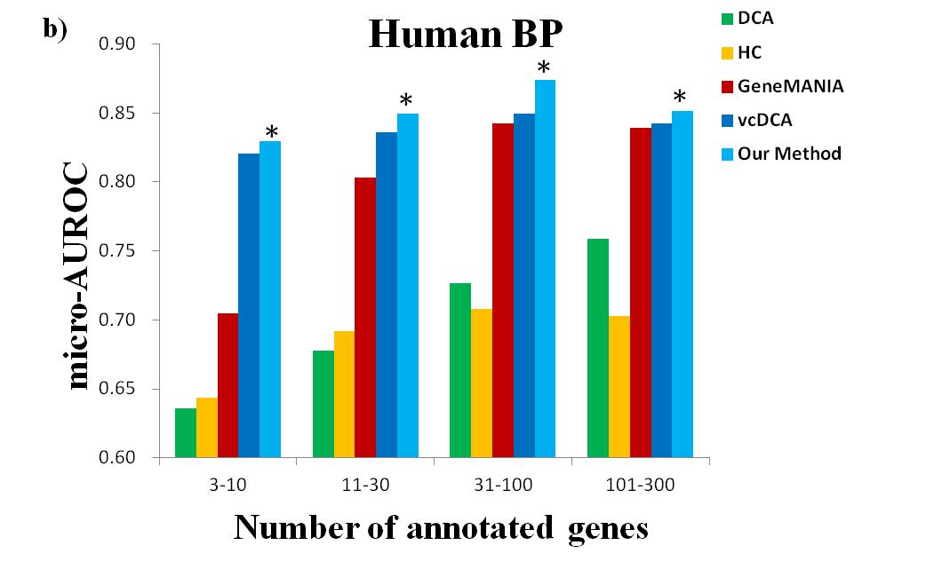

$\frac{∂{MAG}_{i}}{∂θ}=\frac{∂}{∂θ}\left(\frac{F_{i}^{M}B_{i}^{M}}{Z}\right)=\frac{∂F_{i}^{M}}{∂θ}\frac{B_{i}^{M}}{Z}+\frac{∂B_{i}^{M}}{∂θ}\frac{F_{i}^{M}}{Z}-\frac{F_{i}^{M}B_{i}^{M}}{Z}\frac{∂Z}{∂θ}$ 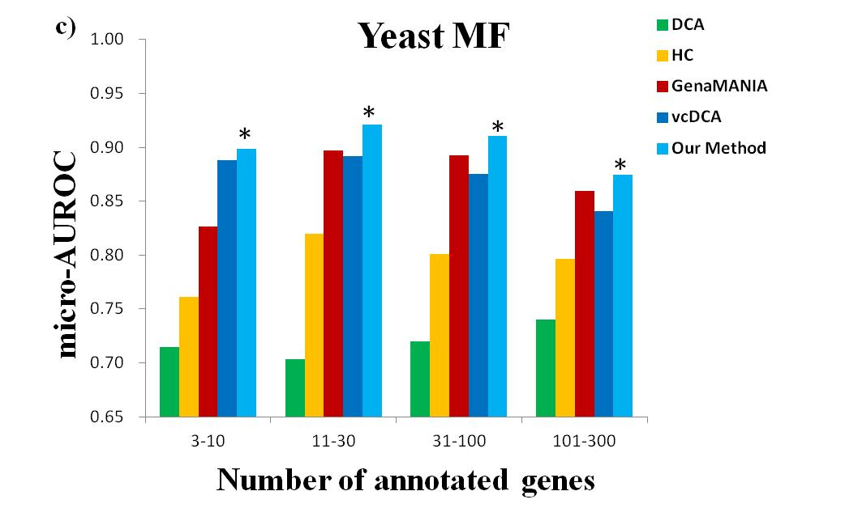

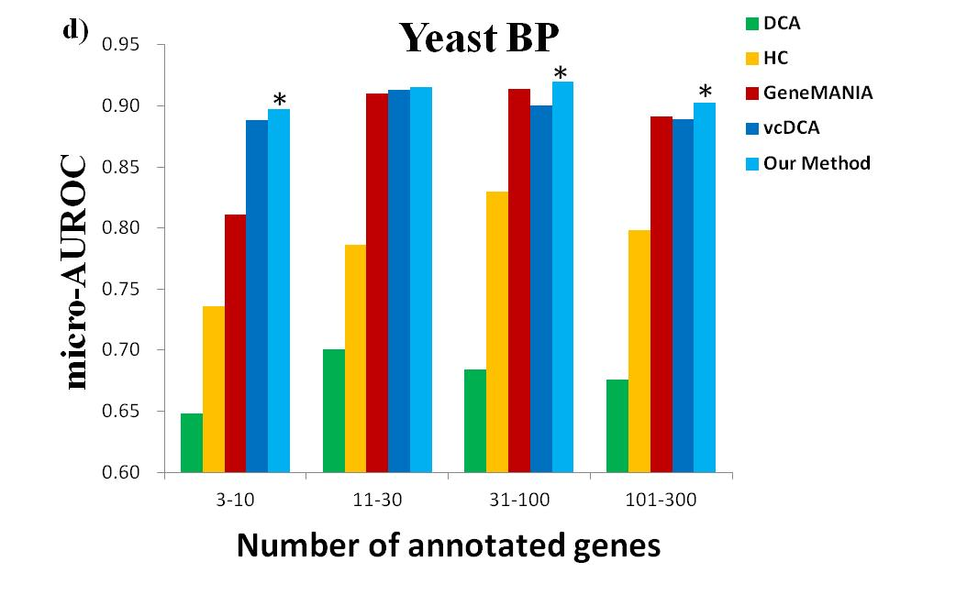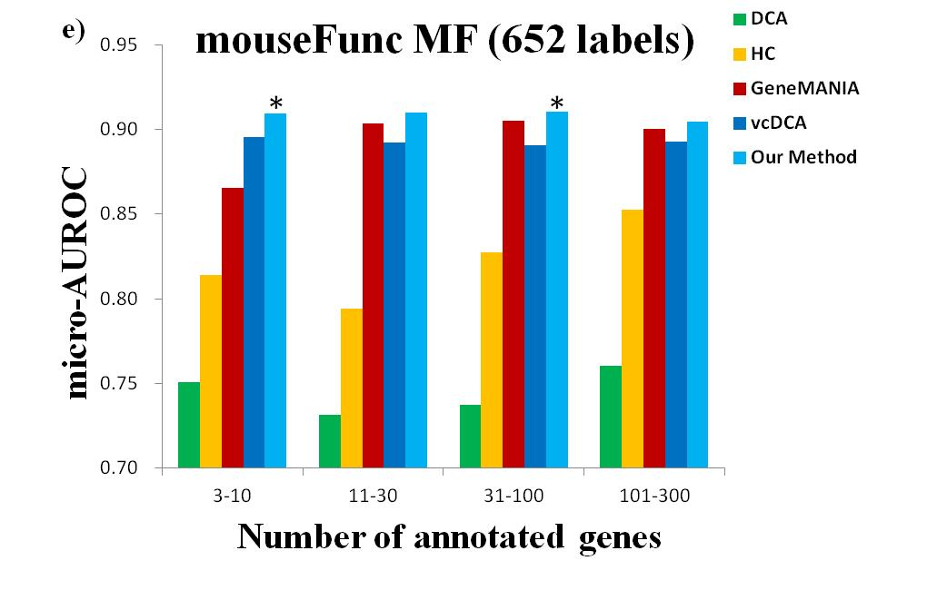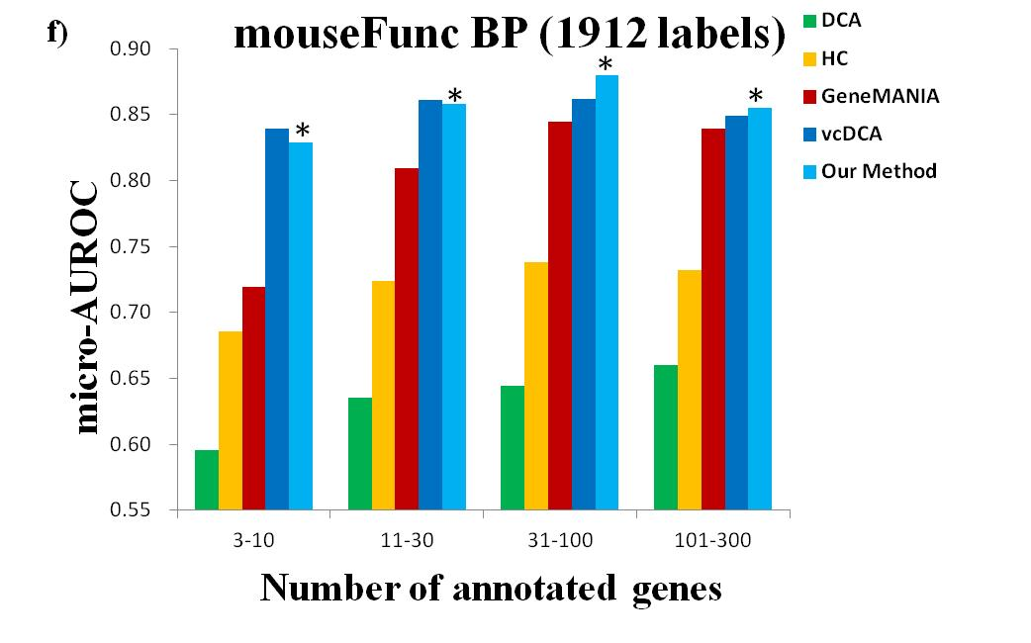

**Figure S4:** Comparison of our approach with other methods in terms of micro-AUROC. * indicates that our approach is statistically significant in comparison with GeneMANIA. Performance is evaluated for different subsets of GO labels with varying sparsity levels as shown on the x-axis.

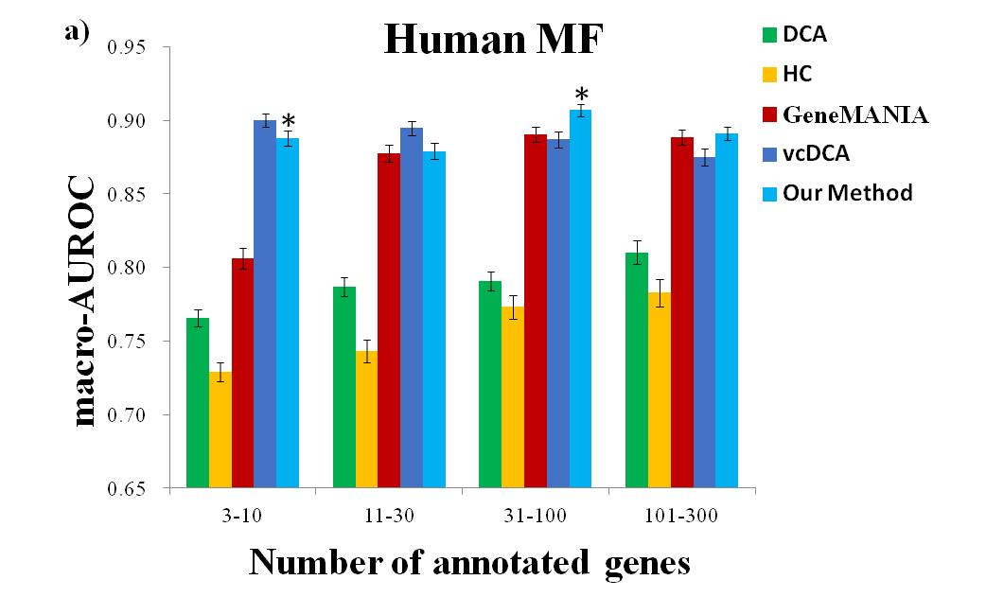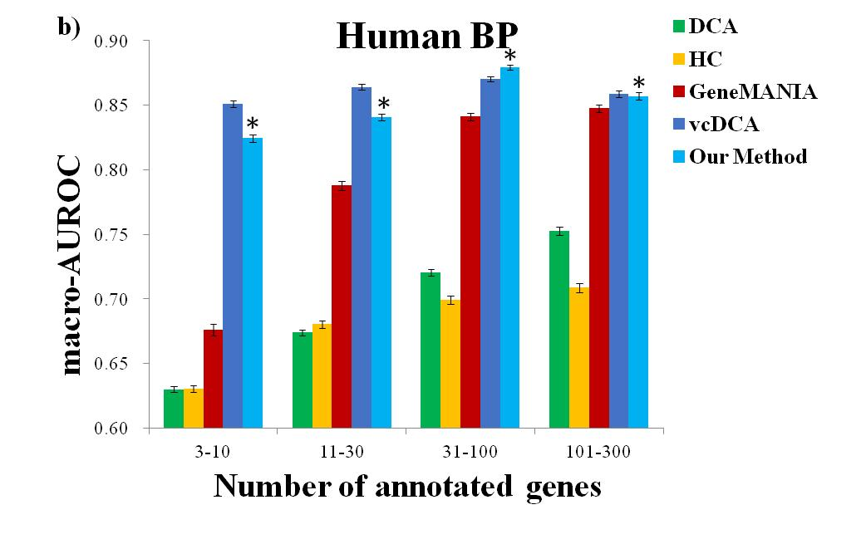

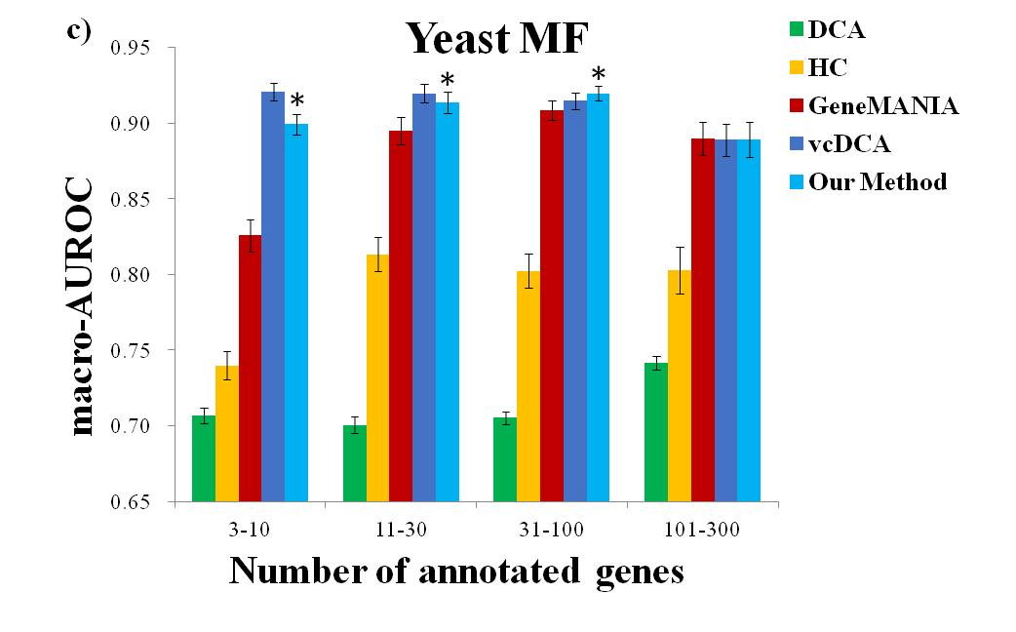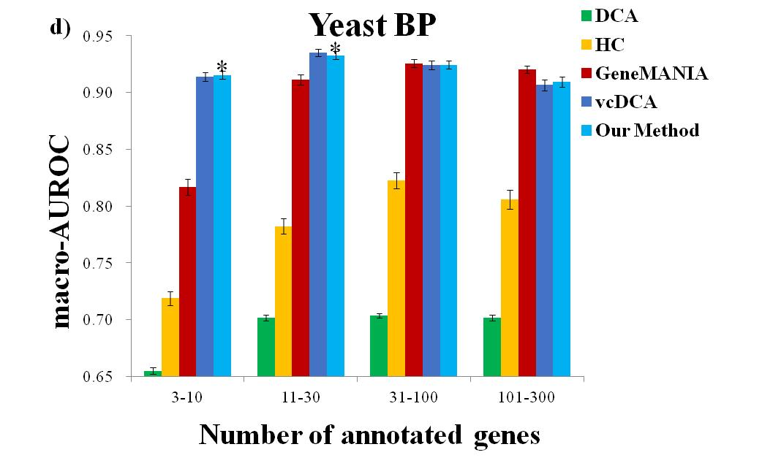

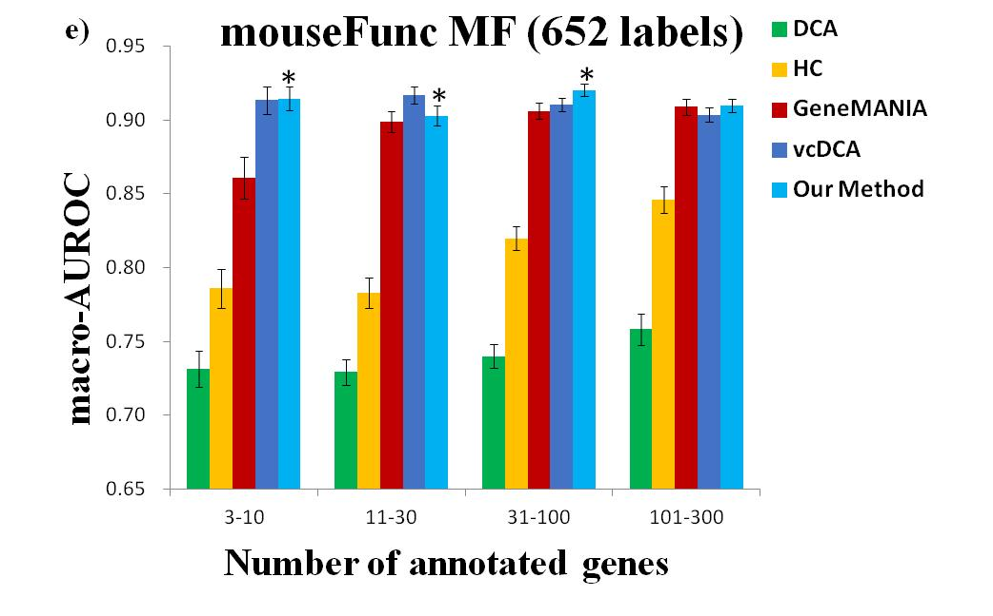

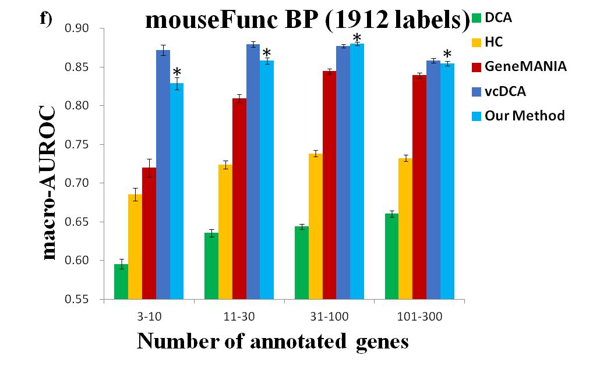

**Figure S5:** Comparison of our approach with other methods in terms of macro-AUROC. * indicates that our approach is statistically significant in comparison with GeneMANIA. Performance is evaluated for different subsets of GO labels with varying sparsity levels as shown on the x-axis.

# Comparison of performance in terms of AP@10 and macro-APRUC

We show the comparison of performance in terms of AP@10 and macro-APRUC in **Table S1** and **Table S2.** In human, our method achieved 0.1317 AUPRC on BP labels with 31-100 annotations, which is slightly higher than 0.1172 AUPRC for GeneMANIA. In yeast, our method achieved 0.3353 AUPRC on MF labels with 101-300 annotations, which is higher than 0.3198 AUPRC for GeneMANIA.

**Table S1:** Comparison of our approach with other methods in terms of AP@10.

|  |  |  |  |  |
| --- | --- | --- | --- | --- |
|  | #annotated  genes | HC | GeneMANIA | clusDCA |
|  | 3-10 | 0.0665 | 0.1265 | **0.1520** |
| Human MF | 11-30 | 0.1517 | 0.2227 | **0.2778** |
|  | 31-100 | 0.2802 | 0.3307 | **0.3944** |
|  | 101-300 | 0.2710 | 0.4642 | **0.5357** |
|  | 3-10 | 0.0253 | 0.0541 | **0.0674** |
| Human BP | 11-30 | 0.0658 | 0.1169 | **0.1338** |
|  | 31-100 | 0.1229 | 0.2457 | **0.3034** |
|  | 101-300 | 0.1829 | 0.3860 | **0.4617** |
|  | 3-10 | 0.0860 | 0.1187 | **0.2748** |
| Yeast MF | 11-30 | 0.2232 | 0.2521 | **0.3832** |
|  | 31-100 | 0.3285 | 0.3911 | **0.5830** |
|  | 101-300 | 0.3177 | 0.4451 | **0.6985** |
|  | 3-10 | 0.0861 | 0.0973 | **0.2253** |
| Yeast BP | 11-30 | 0.2003 | 0.2312 | **0.3666** |
|  | 31-100 | 0.3594 | 0.3837 | **0.5476** |
|  | 101-300 | 0.4184 | 0.4953 | **0.6960** |
|  | 3-10 | 0.0409 | 0.0993 | **0.2331** |
| mouseFunc | 11-30 | 0.1782 | 0.2130 | **0.3283** |
| MF | 31-100 | 0.3061 | 0.2637 | **0.4727** |
|  | 101-300 | 0.3242 | 0.3629 | **0.6012** |
|  | 3-10 | 0.0203 | 0.0406 | **0.0984** |
| mouseFunc | 11-30 | 0.0927 | 0.0958 | **0.1802** |
| BP | 31-100 | 0.1272 | 0.1678 | **0.3105** |
|  | 101-300 | 0.1648 | 0.2504 | **0.3794** |

**Table S2:** Comparison of our approach with other methods in terms of macro-AUPRC.

|  |  |  |  |  |
| --- | --- | --- | --- | --- |
|  | #annotated  genes | HC | GeneMANIA | clusDCA |
|  | 3-10 | 0.0286 | 0.0882 | **0.0988** |
| Human MF | 11-30 | 0.0527 | 0.1430 | **0.1671** |
|  | 31-100 | 0.0602 | 0.1678 | **0.1690** |
|  | 101-300 | 0.0603 | **0.2367** | 0.2133 |
|  | 3-10 | 0.0118 | 0.0368 | **0.0412** |
| Human BP | 11-30 | 0.0285 | 0.0662 | **0.0698** |
|  | 31-100 | 0.0366 | 0.1172 | **0.1317** |
|  | 101-300 | 0.0436 | **0.1764** | 0.1721 |
|  | 3-10 | 0.0403 | 0.0946 | **0.1850** |
| Yeast MF | 11-30 | 0.0740 | 0.1768 | **0.2366** |
|  | 31-100 | 0.0730 | 0.2466 | **0.2721** |
|  | 101-300 | 0.0778 | 0.3198 | **0.3354** |
|  | 3-10 | 0.0412 | 0.0760 | **0.1405** |
| Yeast BP | 11-30 | 0.0867 | 0.1634 | **0.2208** |
|  | 31-100 | 0.1075 | 0.2610 | **0.2791** |
|  | 101-300 | 0.1158 | **0.4010** | 0.3805 |
|  | 3-10 | 0.0150 | 0.0804 | **0.1535** |
| mouseFunc | 11-30 | 0.0534 | 0.1519 | **0.1950** |
| MF | 31-100 | 0.0567 | 0.1664 | **0.2129** |
|  | 101-300 | 0.0596 | **0.2738** | 0.2663 |
|  | 3-10 | 0.0085 | 0.0313 | **0.0615** |
| mouseFunc | 11-30 | 0.0323 | 0.0564 | **0.0865** |
| BP | 31-100 | 0.0345 | 0.0860 | **0.1120** |
|  | 101-300 | 0.0437 | 0.1270 | **0.1328** |

# The complete list of clusters

We show the complete list of clusters here.

